CIS/STA 3920, 7-27-20 Prof. L. Tatum minor edits, clarified question 5.4(b)
Lecture Notes 5: Classification Space for k-NN

Section Topic

1 Graphing the k-NN Classification Space and Standardizing
2 Understanding the R Function NewProbeKnn
3 Classification Space for k-NN on Stock Range
4 Function to Search Across k: kSearch
5 Cross-validation with Knn: kcvSearch
Exercises
Appendix of R Functions

Download the accompanying R workspace. Open that and work along with the following steps. That workspace includes all the variables and functions used. When you can’t find something, use the expression ls( ) to list all the elements I have defined.

Section 1. Graphing the k-NN Classification Space & Standardizing

For a given sample, it is informative to check the k-nn classification decision for a wide range of points. We do this by creating a grid of test points. This helps us to develop some understanding of the characteristics of algorithm and the roll that the k parameter plays. And, it can help us to see if we are using the program correctly, and also if the program is damaged or corrupted.
I have written a program, ProbeKnn, shown in an Appendix, that still takes TrainX and TrainY values, but for the Test data set it inserts a huge number of test points in a two-column vector called ProbeX. I am not going to try see if those forecasts were “correct.” My goal is just to see where knn is predicting cat and where it is predicting dog, and to see of those assignments look sensible.
My ProbeX column contains over 5000 pairs of (Weight, Whisker) values, spread across the observed range of weight values of whisker-length values. If the prediction is Cat, then my program puts down a red + on the graph; for Dog, a green +. I call this cat-dog prediction graph a classification space.
Here is an example, with k=1, for the original 15 Cat and Dog data points. I have saved this as bitmap rather than metafile. That reduces the quality, but it scrolls better.

ProbeKnn(TrainX, ProbeX, TrainY, 1)
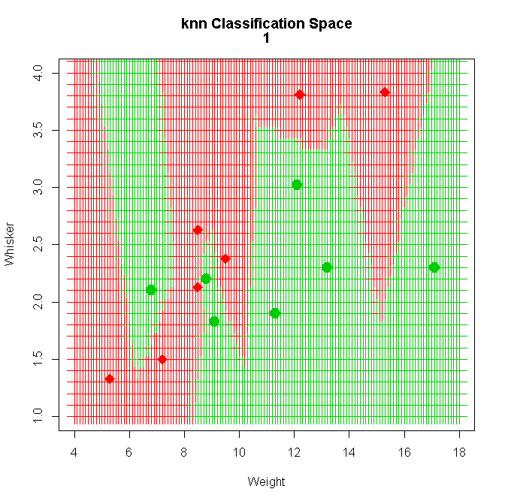

It looks pretty good because the red Cat points from the TrainX are surrounded by red crosses, or predictions of Cat. That should consistently be the case with k=1.
However, something is visibly wrong. Why are there vertical streaks?
The problem is that a length of 1.0 on the vertical axis stretches further than a length of 1.0 on the horizontal axis. That happens because the range of Weight is 18-4 = 16, but the range of Whisker Length is only 4.0-1.0 = 3. When we compute the Pythagorean distance between (x,y) points in this graph, the points show up as closer together in the Whisker direction than in the Weight axis. This means that the algorithm is not actually using circles to decide which neighbors are close; it is using ovals with the longer axis oriented vertically!
To avoid this common problem, it is conventional to standardize each of the x-columns by
(a) subtracting the average of the column, then
(b) dividing the sample standard deviation of the column.
This will generally fix the problem because the scaling can then be forced (in the R plotting expressions) to be same in both directions by using the same minimum and maximum value for the endpoints of the axes values.
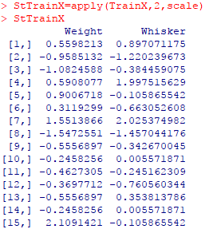
For a small sample from a Normal distribution, the standardized data will usually range from around -2.5 to 2.5. For long-tailed distributions like stock returns, the standardized values will often range from negative 3.0 to 3.0, or even wider. For a large data set with a single wild value we might see an isolated point out at 6 or 7 even after standardization!
A second method of standardization, often used in computer science to, is force the data points to lie between 0 and 1, inclusive. That is done by subtracting the minimum from each value and then dividing by the range. (Walk through it with three or four data points – it’s a good mental exercise.)
The standardization technique is not needed when working with Lag1 and Lag2 for our stock returns because those have the same scaling. That is why in the ISL text we do not encounter standardization until after the knn algorithm has already been run on the stock data. But, if the text had used Lag1 and Volume of shares traded it would certainly have needed to standardize because the number of trades per day runs into the millions for some stocks.
R has a built-in standardization function called scale that subtracts the sample average and divides by the sample standard deviation. I will use that to standardize TrainX, naming the result StTrainX.
StTrainX = apply(TrainX, 2, scale)
I will also create a fresh set of probe values, StProbe, which are evenly spaced over a square ranging from negative 3.0 to 3.0 in increments of 0.1. I have written a modified probe function, NewProbeKnn, shown in the Appendix. Here are the results of running NewProbeKnn with k=1:
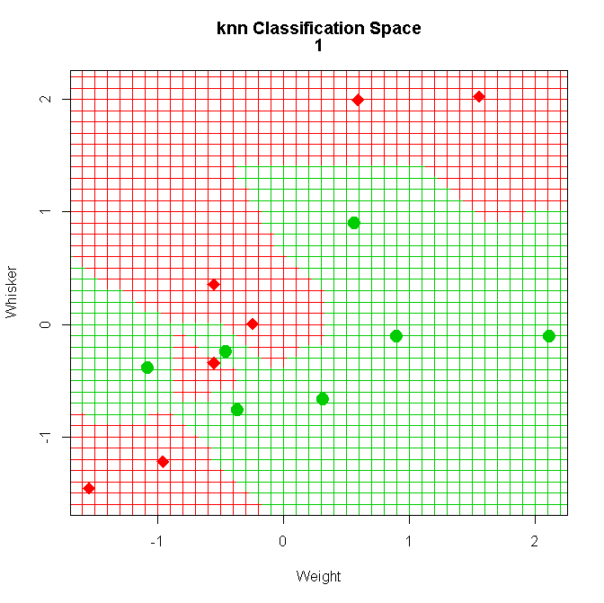

You will immediately see that the vertical streakiness is gone. We can see hints of circular decision rules at work.
On the graph, just below the main title, the value of k has been shown as “1”. This value was inserted quite easily, which is astonishing. Look at NewProbeKnn to see how.

Let’s see what happens for k=3, below.

NewProbeKnn( StTrainX, StProbeX, TrainY, 3 )

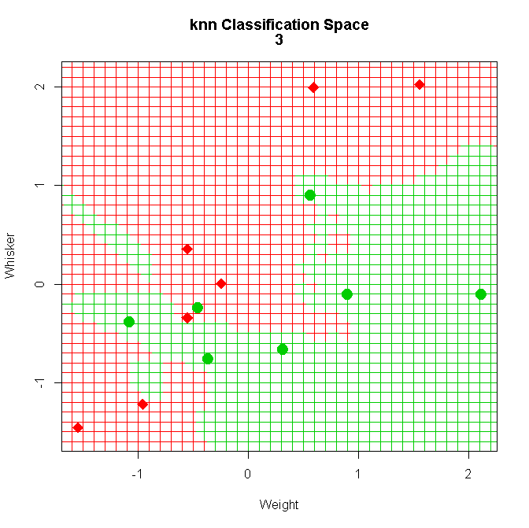

Wow! Who would have guessed we would get that green streak going out to the left – like a ray of sunshine? Over time, I noticed something much more worrisome in an immediate sense. Look at the top circled region. Why are we getting a red intrusion between two green points when k=3? Shouldn’t those all be red? And why does something similar happen below, in the second circle?
After a bit of time, it occurred to me that this could get even stranger. Suppose we try running the exact same data set four different times, with k=3. If we save those plots and compare them, we find we get four clearly different sets of results in the splotchy regions!
Here is another disturbing fact: other packages in R that offer a k-nearest neighbors algorithm do not display the above behavior! To be clear in the following discussion, I am going to term the algorithm we are using as Ripley’s knn, naming it for its principal author, Brian Ripley. An example of an R program that does not display that randomized splotchy behavior with my dog and cat data is Schliep’s kknn algorithm, downloadable from CRAN sites. Schliep’s version offers many extensions to ordinary knn. (You might want to take it up as a project topic.)
After much frustration, I discovered that this strange behavior comes from the combination of two features. The first is that there is a duplicated “cat” row within the first 15 rows of my dog and cat data set – it is not easy to notice unless you know to look for it. Now, consider what happens when k=3 and that double point is the third nearest neighbor. Then, the count of points jumps from 2 to 4 when the double point is included, instead of 3.
The second feature is how the knn program deals with this situation. The default setting for Ripley’s knn program is to include all “ties” in the voting, meaning that the value of k will be increased when ties occur – and the user is not warned. So, in my dog and cat data, we are often ending up with a vote of four animals, even though we asked for k=3. So, when our three nearest neighbors are two dog points and that double-cat point, then we have a tied vote and the algorithm flips a coin. In the classification space, this will produce noticeable chaos!
Once we know about this issue, we can see it is addressed, obliquely, in the R-Documentation for knn from Ripley’s Class Package. Here are the salient passages from the documentation.

********************

knn(train, test, cl, k = 1, l = 0, prob = FALSE, use.all = TRUE)

use.all | controls handling of ties. If true, all distances equal to the kth largest are included. If false, a random selection of distances equal to the kth is chosen to use exactly k neighbors.
********************

What the above shows is that the default setting is TRUE for the “use.all” argument, meaning that all tied points are used in the voting by default. If we set use.all=FALSE, then one of the tied values is selected at random.
This tells us something quite interesting about the general k-nearest neighbors algorithm: this tied-distance issue is complex! For example, suppose my two tied-distance points had been one cat and one dog. Then, we would see splotchy, randomized behavior in the classification space no matter if we set use.all to FALSE or to TRUE!
I have not checked, but I assume that Schliep’s kknn has the opposite default setting, but if we switched one of those cats to a dog, then we would again see randomization in the voting, even with k=3.
Voting, itself, is complicated!

Section 2. Understanding the Details of NewProbeKnn

The basic plotting routines used in NewProbKnn have been covered in the Section 1. There is a new wrinkle, though, in that two different plotting routines have been used to supply input to the same graph. (The same is true of ProbeKnn, too). The first plotting call puts down the classification space, which are the red zones and the green zones. The second plots the Weight and Whisker value of the 25 animals and distinguishes them as Cats or Dogs. That allows us to make a visual inspection of (a) what is happening and (b) if what is happening appears to be correct.
To tie these two plotting commands together, we use a special statement:
par(new=TRUE)
placed between the two plotting calls. That command is pointed out in the “commented” version of the function, CommentNewProbeKnn, shown below, where I call it a bridge.
With this special setting, R s actually placing a second plot directly on top of the first plot. Therefore, we must compel the two plots to have the same range of x-axis values, as well as the same range of y-axis values: otherwise we get off-set images.
In my probe functions, I insured that the same x-ranges were employed by using the MinX and MaxX steps. Recall that that the TrainX input (and its standardized version, StTrainX) contains an x1-column of Weight and an x2-column of Whisker. Although both x1 and x2 have been standardized, that does not mean that we know the exact minimum and maximum of each. By plotting from minimum of both x and y to the maximum of both x1 and x2, all the points will fit in the plotting region. And, this delivers to a square plotting grid with equal ranges on the x1- and x2-axes. And, by passing this same plotting range to the second plot, the two plots are seamlessly placed, one on top of the other.
A warning: in these R programs, interpret the term TrialX as the same as TrainX, and likewise for TrialY as the same as TrainY.
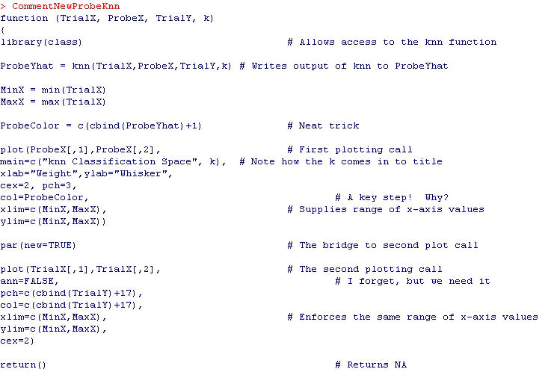

Section 3. Classification Space for k-NN on Stock Range

Step1: Start in Section 5 of LN4 at the conversion of Y.IBM to a factor data type.

Step 2: I am now going to introduce a new wrinkle: the natural log transformation of the range values. This removes heteroscedasticity from the lag1 and lag2 variables. Then, I will standardize the lag1 and lag2 variables to facilitate the plotting of the classification space. I will try k=25, using a function NewProbeKnnBig, created to handle the plotting of so many data “training” points.
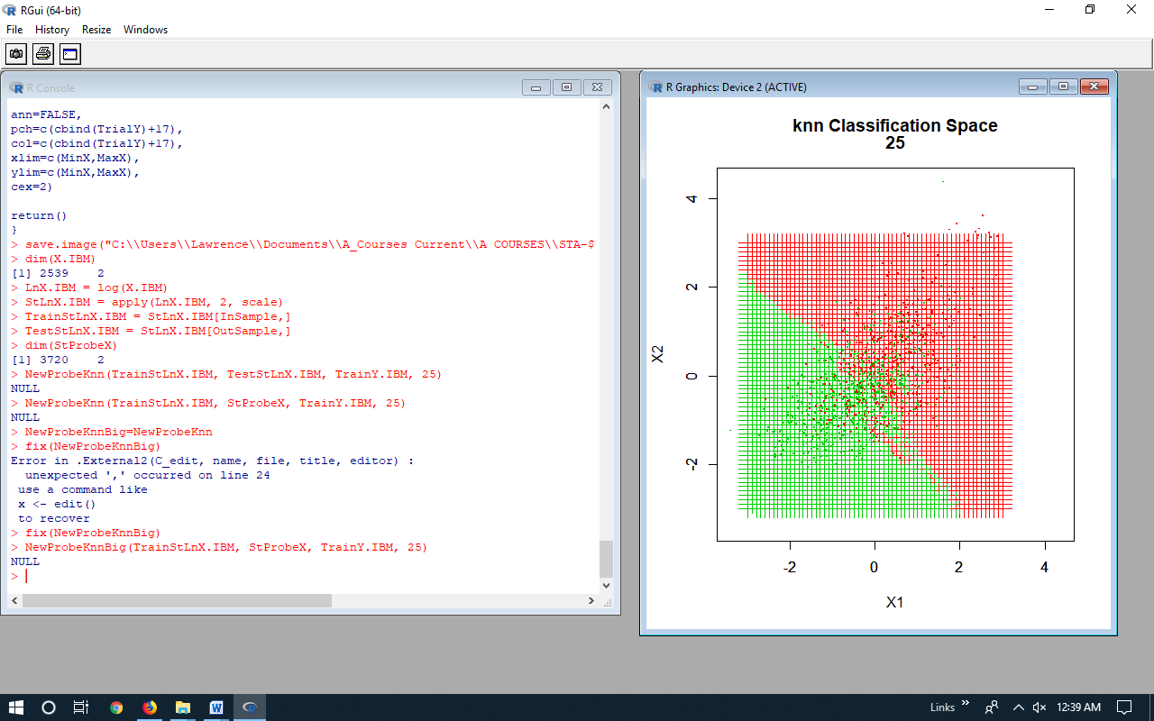

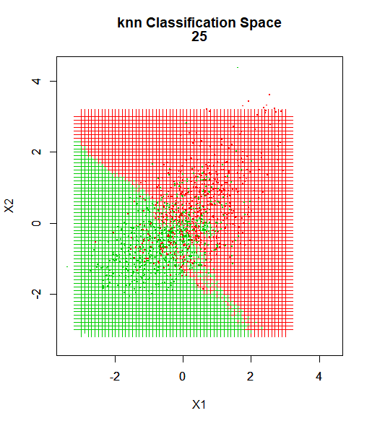

This is a beautiful plot because we can see – in some sense – where the misclassifications occur. However, the data points that are shown (green for LowRisk, red for HighRisk), are for the training data. That is, a red point in the green area is a HighRisk point that was predicted to be LowRisk even though that point is “InSample.”
Of course, we would like to show the classifications of the “OutSample” points, but this is enough for today!

Here is the result for k=5.

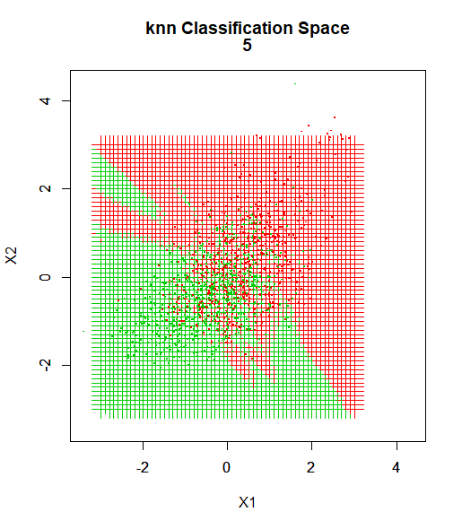
An interesting tangle, and somewhat humbling! I think the graphics would be better if classification spaces were denoted by shading rather than with crosses.

Section 4. Function to Search Across k: kSearch
The following function, “kSearch”, allows the user to search across many values of k. It also allows for the choice of the splitting point, and uses randomized shuffling of the data.
The X input should be a data frame and can contain any number of columns. The Y input must be a factor data type, with the same number of rows as the X input. If Y is not a factor, the program will stop and show a warning message. Likewise, if X is not a data frame.
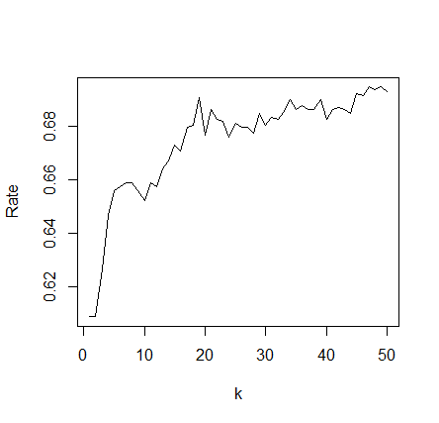
The “split” argument determines the size of the training data, and “d” gives the maximum value of k. The output is a vector of length d which holds the correct classification rate for each d. Here is an example, using the variables defined in the LN5 6-22-18.RData file.

> junk = kSearch(X.IBM,Y.IBM,1200,50)
> plot(junk,type="l",ylab="Rate",xlab="k")

kSearch =
function (X,Y,split=100, d=25)
{
if(class(Y)!= "factor") stop('Y is not factor type')
if(class(X)!= "data.frame") stop('X is not data.frame type')
rows = nrow(X)
Hold = rep(NA,d)
Shuffle=sample(rows,rows)
for(k in 1:d) {
InSample=Shuffle[1:split]
OutSample=Shuffle[(split+1):rows]
TrainX = X[InSample,]
TrainY = Y[InSample]
TestX = X[OutSample,]
TestY = Y[OutSample]
knn.pred = knn(TrainX, TestX, TrainY, k)
table.out = table(knn.pred,TestY)
Hold[k] = (table.out[1,1]+table.out[2,2])/sum(table.out)
}
return(Hold)
}
Section 5. Cross-validation with knn: kcvSearch
While randomly splitting the data and searching across many values of k are good ideas, the possibility remains that our “best” choice of the value k will be driven by the particular random split that occurred. To overcome this source of random variation, for each value of k generate numerous different random splits and then average the correct classification rates that result. This is termed “cross-validation.”
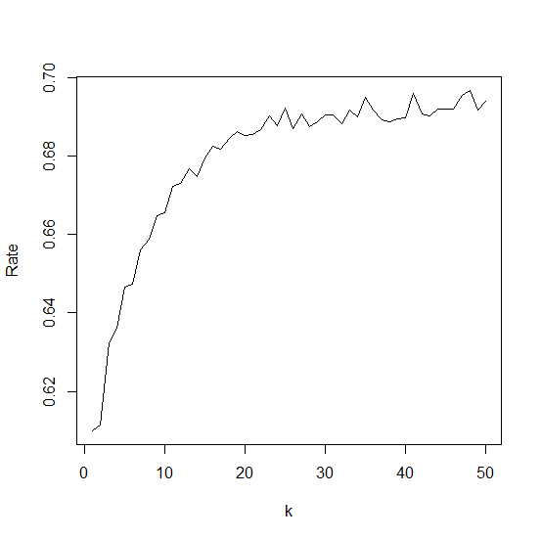
Here is a program, kcvSearch, that does that. The new parameter, m, is the number of random splits. The higher m, the smoother the plot will be of k versus classification rate, but the longer the program will run.
> junk = kcvSearch(X.IBM,Y.IBM,1200,50,30)
> plot(junk,type="l",ylab="Rate",xlab="k")

> kcvSearch =
function (X,Y,split=100, d=25, m=10)
{
if(class(Y)!= "factor") stop('Y is not factor type')
if(class(X)!= "data.frame") stop('X is not data.frame type')
rows = nrow(X)
Hold = rep(NA,d)

for(k in 1:d) {
Store = rep(NA, m)

for(j in 1:m) {
Shuffle=sample(rows,rows)
InSample=Shuffle[1:split]
OutSample=Shuffle[(split+1):rows]
TrainX = X[InSample,]
TrainY = Y[InSample]
TestX = X[OutSample,]
TestY = Y[OutSample]
knn.pred = knn(TrainX, TestX, TrainY, k)
table.out = table(knn.pred,TestY)
Store[j] = (table.out[1,1]+table.out[2,2])/sum(table.out)
}
Hold[k] = mean(Store)
}
return(Hold)
}
LN5. Exercises

Warm-up: For your own good, work through Sections 1 to 5 using R; show that work in an appendix to this assignment. (An appendix goes at the back of a document, not the front.)

5.1 Use the Daily Range data for your stock, as in Section 3. Use the classification of HighRisk/LowRisk as the y-variable and use the natural logs of your lag ranges as your two-dimensional x-variables. Standardize the logged lag variables. Then, create a classification-space-test data set, if my version is not appropriate. Then run the “NewProbeKnnBig” program on your data and show the classification space you get for a few different values of k. Discuss what you find.

5.2 Apply the kSearch program in Section 4 to your logged range data. Discuss problems and findings.

5.3 Apply the kcvSearch program in Section 5 to your logged range data. Discuss problems and findings.

5.4 Original work: Take a try at one of these two explorations:
(a) To this point, we have used Excel to create grids of points in Excel. There are many ways to create rectangular grids of points within R. Search on that topic, show results of the searches, and your efforts to employ the method(s) to create test-grids for our use.

(b) In my plot on page 8, the plot is not fully satisfactory. See if you can find a way to shade the red region, say, rather than show it as red crosses. Then there will be no need to show the green region – it will just be white. Try making other improvements as they occur to you, such as including a legend. For the truly adventurous, you could try to modify NewProbeKnnBig to show the forecast points for the test data rather than for the training data, and to then perhaps highlight data points which were misclassified!

To make a change to NewProbeKnnBig, we need to open it in an editor. The simplest way to do this is to use the "fix" editor function. I would make a second copy to work from so you don't damage the original, say, type
MyNewProbKnnBig = NewProbKnnBig
then type
fix(MyNewProbKnnBig)

and you can edit that. In particular, you could modify things like the ProbeColor command or other arguments to the plot function such as pch.

Appendix of R Functions: ProbeKnn, NewProbeKnn, NewProbeKnnBig

It is my intention that these functions can be copied and pasted directly into R.

ProbeKnn <-
function (TrainX, ProbeX, TrainY, k)
{
library(class)

ProbeYhat = knn(TrainX,ProbeX,TrainY,k)

ProbeColor = c(cbind(ProbeYhat)+1)

plot(ProbeX[,1],ProbeX[,2],
main=c("knn Classification Space", k),
xlab="Weight",
ylab="Whisker",
cex=2,
pch=3,
col=ProbeColor,
xlim=c(4,18),
ylim=c(1,4))

par(new=TRUE)

plot(TrainX[,1],TrainX[,2],
ann=FALSE,
pch=c(cbind(TrainY)+17),
col=c(cbind(TrainY)+17),
xlim=c(4,18),
ylim=c(1,4),
cex=2)

return()
}

Modified NewProbeKnn, 6-19-18
Now prints X1 and X2 as axis labels. (Contained in LN5 6-20-18.RData)

NewProbeKnn =
function (TrialX, ProbeX, TrialY, k)
{
library(class)

ProbeYhat = knn(TrialX,ProbeX,TrialY,k)

MinX = min(TrialX)
MaxX = max(TrialX)

ProbeColor = c(cbind(ProbeYhat)+1)

plot(ProbeX[,1],ProbeX[,2],
main=c("knn Classification Space", k),
xlab="X1",ylab="X2",
cex=2, pch=3,
col=ProbeColor,
xlim=c(MinX,MaxX),
ylim=c(MinX,MaxX))

par(new=TRUE)

plot(TrialX[,1],TrialX[,2],
ann=FALSE,
pch=c(cbind(TrialY)+17),
col=c(cbind(TrialY)+17),
xlim=c(MinX,MaxX),
ylim=c(MinX,MaxX),
cex=2)

return()
}

NewProbeKnnBig, 6-20-18
Handles large data sets. (Contained in LN5 6-20-18.RData)

NewProbeKnnBig =
function (TrialX, ProbeX, TrialY, k)
{
library(class)

ProbeYhat = knn(TrialX,ProbeX,TrialY,k)

MinX = min(TrialX)
MaxX = max(TrialX)

ProbeColor = c(cbind(ProbeYhat)+1)

plot(ProbeX[,1],ProbeX[,2],
main=c("knn Classification Space", k),
xlab="X1",ylab="X2",
cex=2, pch=3,
col=ProbeColor,
xlim=c(MinX,MaxX),
ylim=c(MinX,MaxX))

par(new=TRUE)

plot(TrialX[,1],TrialX[,2],
ann=FALSE,
pch=".",
col=c(cbind(TrialY)+17),
xlim=c(MinX,MaxX),
ylim=c(MinX,MaxX),
cex=2)

return()
}

